**Lab#3 Building a Rest API to support the creation of a new account and customer details.**

In this lab we are creating the API that will allow the creation of a new account and customer.

----------------------------------------------------------------------------------------------------------------

Note: If you have problems with Lombok

<https://stackoverflow.com/questions/35842751/lombok-not-working-with-sts>

-----------------------------------------------------------------------------------------------------------------

1. Add class AccountsConstants provided to a new package com.tus.accounts.constants. This class will store error messages.

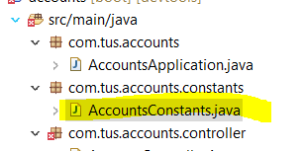

1. Update the AccountController class for the PostMapping as shown. You can add /accounts to the PostMapping path

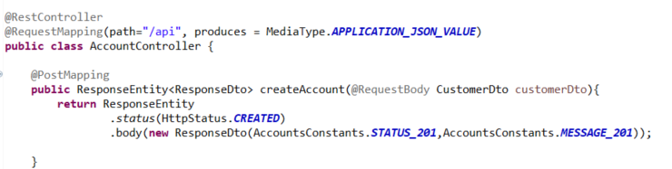

1. Add a packages service and serviceImpl. These will hold the interface for the Service layer and its implementation. Note: don’t need to use @Autowired in Springboot 3.

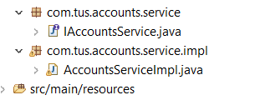

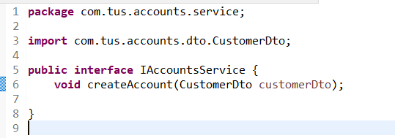

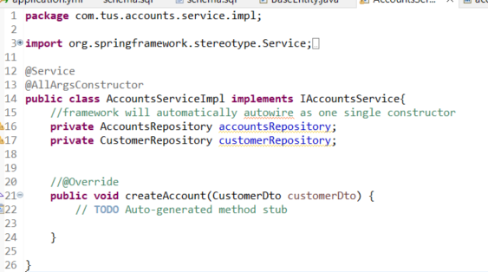

1. We will now create a mapper class (code given) for AccountsMapper and CustomerMapper. This is to map data between the Entity classes and the DTO classes.

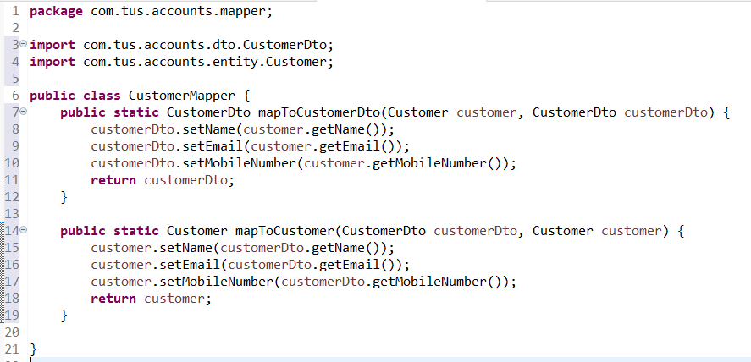

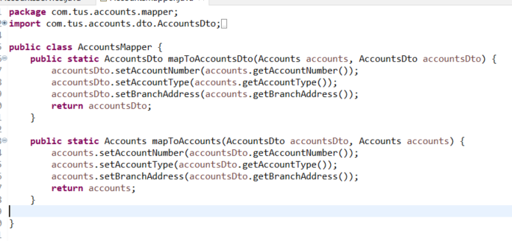

1. Update the AccountsServiceImpl with the method for creating a new account base on a CustomerDto object.

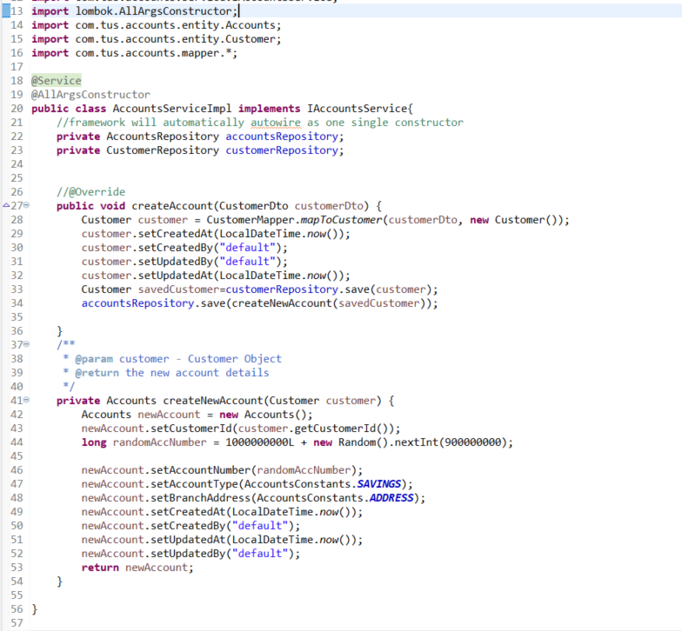

1. Update the controller to call the service layer

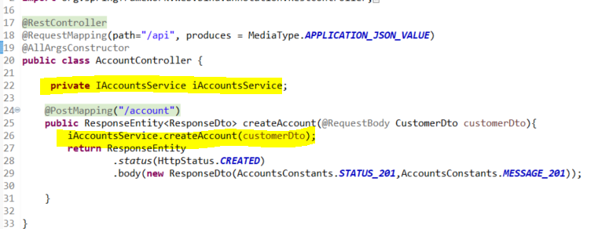

1. Run the project and check the h2-console. The tables should be created and empty.

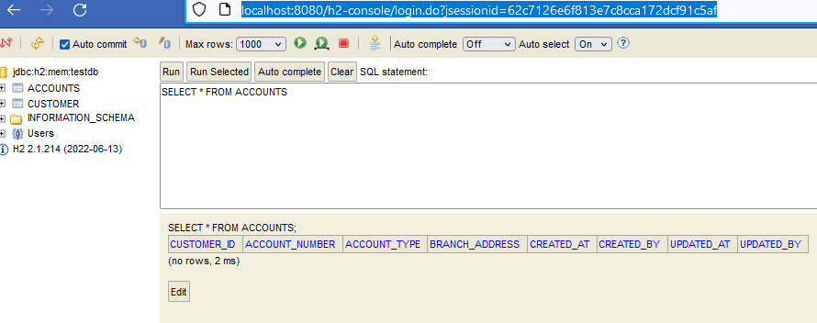

1. Create a new customer from postman. You should get response code 201 and message as shown below.

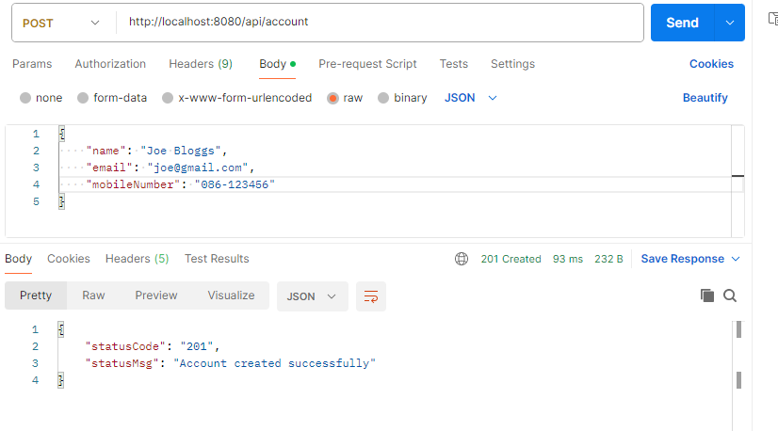

1. Check that the data has been written to the database

